| Juiceshop Walkthrough Diploma in CSF  Year 3 Apr 2022 (Semester 5) | 3 Stars |
| --- | --- |
| Practical |
| Upload Type | |

**OBJECTIVES**

* Learning how to exploit the insecure deserialization vulnerability and manipulate the complaint section.
* OWASP vulnerabilities:Insecure Deserialization, Software and Data Integrity(A08:2017, A08:2021)

**Prerequisite**

* Burp Suite
* Continuation from Upload Size

**Challenge – Upload Type**

* Upload a file that has no .pdf or .zip extension.
* Upload Type - Difficulty: 3/6 stars

**Step 1**

To also complete the Upload Type challenge, in the Repeater, change the .pdf to .png

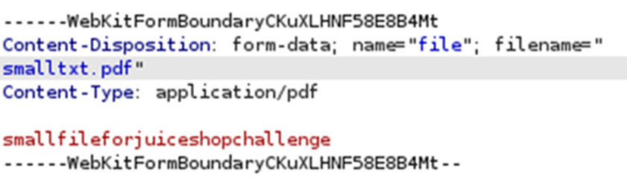

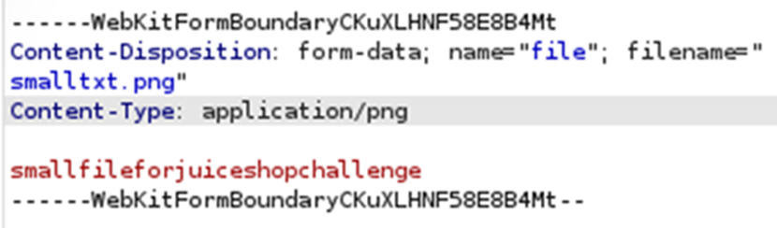

**Step 2**

Click and the challenge is complete.



**~ End of Practical~**